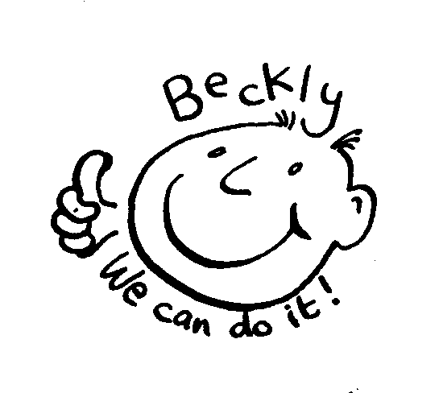
Beckly Adult Social Group
Monday evenings 7pm to 9pm

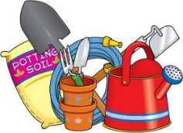
Monday 11th June Social evening
Come along and join in some work in the Beckly garden,

Monday 25th June Evening Walk on the Hoe
Meet Mayflower Steps at 7pm for a circular walk along the Hoe and then to the Barbican for ice cream Collect at 9.00pm at Mayflower Steps
Bring extra money for whatever you want to drink and eat

Monday 9th July Social & Craft evening
Come along and enjoy some arts and crafts
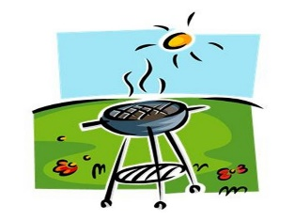
Monday 24th July Summer BBQ
Bring along your favourite ingredients to cook on the BBQ, we will make some healthy salads and dressings to have with what you cook

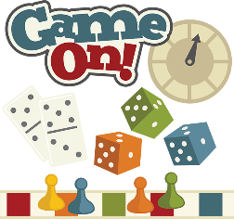
Monday 31st July Social and Games evening
What’s your favourite game come along, play and share your skills

Charge for sessions is £5.00 per evening
Please let us know if any of your details have changed so we can update our records

We need more people to regularly join in our activities so encourage your friends and colleagues to come along to the group... the more people the merrier and the more activities we will be able to do If you can put copies of this timetable up on notice boards or hand out at college, in day centres, to social groups or at work then let us know

Contact us if you have any queries or need more details
Ring on 484433 or email: beckly@routeways.org.uk
keep up to date www.facebook.com/becklycentre

