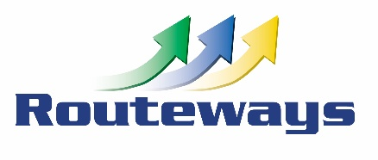
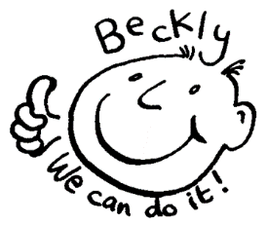
Beckly Centre,
Mayers Way Plymouth PL9 9DF
01752 484433 or 07780662391
www.facebook.com/BecklyCentre |  | Email beckly@routeways.org.uk
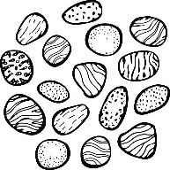
Autumn Weekend Session Session times 10:30 – 15:30

Sat 8th September pebble art
Make some more pebble art and hide those made over the summer
(bus passes / bus fare needed)
Sat 15th September Sugar free challenge
Spotlight on healthy eating and how we can reduce sugary foods
Sat 22nd September Great English Brunch
By popular request we will be cooking a late breakfast / early lunch
and finding ways of making it healthy eating!! Small packed lunch only

Sat 29th September Plymouth arts weekend
show off your artistic skills in our arts competition

Sat 6th October World Animal Day
Celebrate all the different animals and bring along your favourite
cuddly toy for an animal tea party at Beckly

Sat 13th October Here comes the autumn
out and about checking out the changes in nature for Autumn
Sat 20th October Autumn cooking
create a Bake off special dish using autumn ingredients
Payment Details: Cheques should be made payable to Routeways Centre Ltd.
Bank Transfer/Internet Banking: Please put your surname and Beckly in the reference so that we can identify the payment.
Name: Routeways Centre Limited | Account no: 40800741 |  | Sort Code: 56-00-63
Cancellation Policy: Sessions booked will be charged for and all sessions should be paid for in advance.
Where cancellation notice is received more than 5 working days in advance of the booked date then a charge of 25% of session fee will be due, where cancellation is within 5 working days then charge of 100% of session fee will be due
complete this section & return to Beckly OR email us direct with the bookings beckly@routeways.org.uk
Name of Young Person
Contact Email/Phone
Autumn weekend Sessions |  |  | Sat 8th September |  | Sat 15th September
Sat 22nd September |  |  | Sat 29th September |  | Sat 6th October
Sat 13th October |  |  | Sat 20th October

Charge for each session is £32.50 payable in advance for direct personal bookings only
For bookings as part of Care Plans, by Local Authorities and other Agencies please contact us

